
HOTEL SOLUN

Dear Valued Associates,

We thank you for your successful cooperation thus far, and we hope that during this year
Hotel Solun – Skopje will be your first choice for accommodation of your guests.
We look forward to wishing you a warm welcome.

HOTEL SOLUN ACCOMMODATION FACILITIES

Hotel Solun is the first eco-hotel on the Balkans that provides a unique experience to each and every one of our guests, ensuring they are entirely satisfied with all aspects of their visit.
Located in the center of Skopje, Hotel Solun has 10 different types of rooms all specially designed to satisfy the needs for business travelers and tourists. As of 23rd May 2013 the total accommodation capacity of Hotel Solun is 53 rooms, and they can all be used as single or double/twin rooms.
Beside the sophisticated interior design, all types of rooms are equipped with: fresh air cooling and heating system, handmade furniture, bathroom(SOS signal), hair-dryer, satellite TV(LAN connected), Wi-Fi internet connection, Safe Box, direct telephone line and fire protection system.
.

As measurement for the safety of our guests, Hotel Solun had installed

- Fire Hydrants
- Fire proof mattresses
- Fire proof pillows
- Fire proof curtains
- Fire proof walls
- PP System
- Fire proof doors
- Fresh Ventilation System (heating and cooling)
- Electrical installation – Halogen free
- Sprinkle System (in every guest room and public surfaces)
- EVAC System (in every guest room and public surfaces)

As the first ECO hotel on the Balkans Hotel Solun has also implemented

- Non-toxic cleaning agents and laundry detergent
- 100% organic cotton sheets, towel and mattresses
- Non-smoking environment
- Renewable energy sources, solar panels and geothermal pumps
- Bulk organic soap and amenities instead of individual packages to reduce waste
- Hotel lobby recycling bins
- Hotel rooms lighting and TV’s are LED technology and mini-bars are eco smart
- Serve organic and local grown food
- Draw-well water
- Newspaper paper recycling program

HOTEL SOLUN
Accommodation

OFFICIAL ROOM RATES *season 2015-2016
No.of rooms | Type of room | Room rate per night/single use | Room rate per night/double use
4 | Standard Single Room | 83 EUR | 103 EUR
8 | Standard Double Room | 93 EUR | 113 EUR
5 | Premium Double Room | 110 EUR | 130 EUR
8 | Junior Business Room | 116 EUR | 136 EUR
4 | Deluxe Room  Twin bed | 127 EUR | 147 EUR
5 | Diplomatic Room  Twin bed | 144 EUR | 164 EUR
4 | Premium Room | 176 EUR | 196 EUR
5 | Business Double  Room  Twin bed | 107 EUR | 127 EUR
5 | Deluxe Diplomatic  Suite | 132 EUR | 152 EUR
5 | Deluxe Diplomatic  Suite 2 | 166 EUR | 186 EUR

*Prices are with VAT
* Includes one overnight, breakfast buffet, Wi-Fi Internet, tourist tax, and VAT.
*Please Note - free Fitness access for Junior Business Room, Deluxe Room. Diplomatic Room, Deluxe Diplomatic Room 1,

Premium Room & Deluxe Diplomatic Room2 have free SPA & Fitness access

HOTEL SOLUN

Meeting  room | Floor | Theatre | Classroom | 'U''  Boardroom | ''I''  Boardroom | 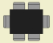  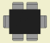 | Area(m2) | Height(m)
1 | 1 | 70-80 | 50-60 | 40-45 | 50 | 45 | 100 | 3.2

CONFERENCE HALL RENTAL
Rental of Conference Hall for one day : - - - - - - - - - - - - - - - --- 300EUR

Includes:
use of conference hall, flipchart, Paper for flipchart, Projector FREE of charge, WiFi connection – bottles of water 0.5x2, folder, pens, and notebook for every participant, Service)

Rental of Conference Hall for 1 Hour: - - - - - - - - - - - - - - -- - - -- 65 EUR
Includes :
use of conference hall, flipchart, Paper for flipchart, Projector FREE of charge, WiFi connection – bottles of water 0.5x1, folder, pens, and notebook for every participant, Service)

*Additional Equipment rental is available upon request, at an additional price.

*Prices are with VAT

On these prices for rental of the conference room we can approve -10%discount

HOTEL SOLUN

COFFEE BREAK

1. Coffee break per person per break: - - - - - - - - - - - - - - - - - 2.50 Euro
Filter Coffee, Tea and Cookies

2. Coffee break per person per break: - - - - - - - - - - - - - - - - - 3.50 Euro
Filter Coffee, Tea, Milk, Juice, Cookies & Fruit

3. Coffee break per person per break: - - - - - - - - - - - - - - - - - 4.50 Euro
Filter Coffee, Tea, Milk, Juice, Cookies, Fruit & Mini Sandwiches

4. Coffee break per person per break: - - - - - - - - - - - - - - - - - 3.50 Euro
Macchiato, Espresso, Cappuccino Tea and Cookies

5. Coffee break per person per break: - - - - - - - - - - - - - - - - - 4.50 Euro
Macchiato, Espresso ,Cappuccino Tea, Milk, Juice, Cookies & Fruit

6. Coffee break per person per break: - - - - - - - - - - - - - - - - - 5.50 Euro
Macchiato, Espresso, Cappuccino Tea, Milk, Juice, Cookies, Fruit & Mini Sandwiches

7. Coffee break per person per break: - - - - - - - - - - - - - - - - - - - 5 Euro
Filter Coffee, Tea ,Coca-Cola, Fanta, Sprite, Schweppes, Water or Juice and Mini Sandwiches with ham

*Additional Equipment rental is available upon request, at an additional price.

*Prices are with VAT

* Equipment Rental Price List *

EQUIPMENT FOR SIMULTANEOUS & CONFERENCE INTERPRETATION | Price per unit  With 18% VAT.
*Equipment for Simultaneous Interpretation-2 channels  *Receivers/Headphones– price per set(1 receiver and headphones) | 4 Eur
*Equipment for Simultaneous Interpretation-3 channels  *Receivers/Headphones– price per set(1 receiver and headphones) | 5.50 Eur
*Equipment for Simultaneous Interpretation-4 channels  *Receivers/Headphones– price per set(1 receiver and headphones) | 7 Eur
*Equipment for Simultaneous Interpretation-5 channels  *Receivers/Headphones– price per set(1 receiver and headphones) | 7.50 Eur
*Simultaneous Interpretation Booths with ISO standard - 1pcs. | 59 Eur
*Sound System - 1pcs. | 59 Eur
*Static Microphones - 1pcs. | 5.50 Eur
*Wireless Microphone - 1pcs. | 18 Eur
*Clip on microphone - 1pcs. | 29 Eur
*Conference Equipment Engineer | 35.50 Eur
*Data Projector - 1pcs. + Screen | 90 Eur
*LAPTOP Computer - Notebook Pentium IV - 1pcs. | 49 Eur
Note: Number of minimum receivers/headphones to be rented is 20pcs.

TRANSLATION SERVICES-SIMULTANEOUS INTERPRETATION | Price per interpreter,  With 18% VAT. | Total price for two Interpreters, per one day,  With 18% VAT.
*Simultaneous Interpretation per two  interpreters (full day engagement) | 177 Eur | 354 Eur

Note for translation services:
* If the interpretation exceeds 3 hours, counts as one full day
* If the interpretation last more than 1 hour, two (2) interpreters are engaged
* the prices are with VAT
*You can not bring equipment from outside

HOTEL SOLUN

Offer for Art of SPA & FitnesS

Welcome to ART of Spa, by Hotel Solun.
A place where the feeling of home provides a natural sense of calm and relaxation.

Here you will find a warm atmosphere and a new kind of experience, where you are the master of your wellness journey. With each visit you will bask in luxurious aroma, tea, music and healthy snacks.
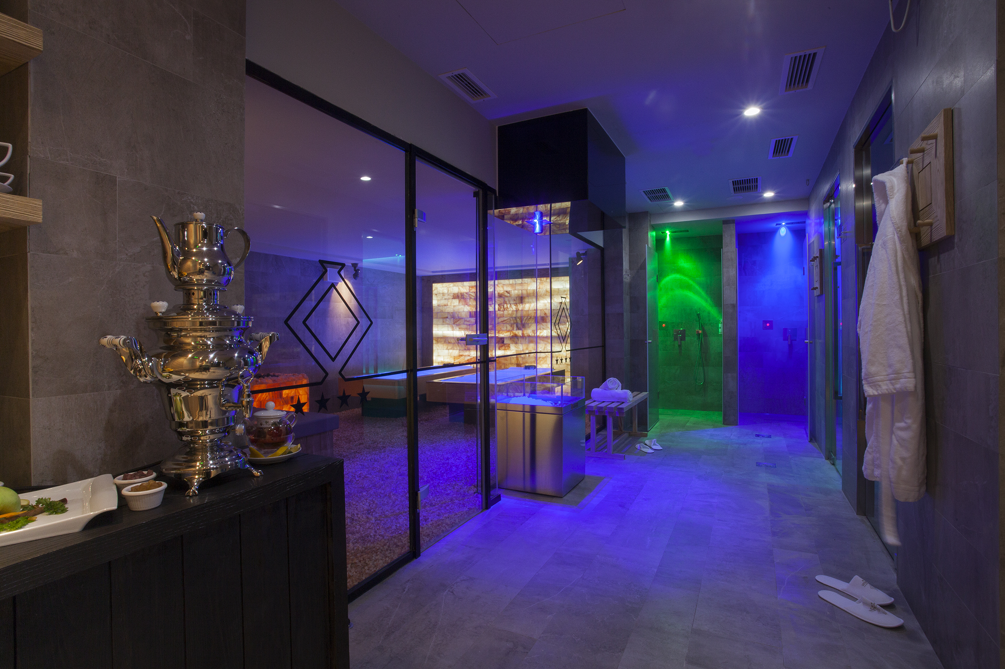

Within these walls you will experience inspiration reflection and discovery created by the surroundings. The concept is simple, limited access means enjoying the spa privately, come and feel the difference.
Relax your muscles, mind and soul with a visit to our Sauna, Steam room or refreshing Ice-shower to complete any day.

Hotel Guest Can Enjoy Full Spa Access For 15 Eur Per Day

MASSAGES

HOT-STONE Massage (1 hour – full body) -------------- 30 EUR

DEEP TISSUE Massage (1 Hour – full body) ------------ 25 EUR

SPORTS Massage (1 Hour – full body) -------------------- 25 EUR

SWEDISH Massage (1 Hour - full body) ------------------ 20 EUR

RELAXING Massage (1 Hour - full body) ---------------- 20 EUR

AROMATHERAPY Massage (1 Hour - full body) ------20 EUR

BACK Massage (30 min) ------------------------------------- 12 EUR



Cocktail & Buffet Menus | HOTEL SOLUN

Menu 1 ~ Cocktail~
(14 EUR)

Snacks (Almonds, Hazelnuts, Walnuts)
Апетисани (лешник,бадем,индиски ореви)

Canapé (Mixed Canape’s with prosciutto, tuna, and cheese)
Канапеи (Со пршута, туна и сирења)

Savory Pasties (Puff pastries with cheese and spinach)
Пити (кифли,пита со сирење,пита со спанаќ)

Caprese Salad | Капрезе
(Домат, Моцарела и босилок)

Charcuterie Plate (A selection of dry meats, smoked chicken, salami and more)
Сувомеснат ордевер (пилешко чадено,кулен,свински врат)

Cheese Platter (A selection of local cheese & mozzarella)
Сирење ордевер (мешано сирење,мешан кашкавал,моцарела)

Main Dish (Chicken, Meatballs in Tomato sauce, Pork or Chicken Rolls)
Главно јадење (пилешко,бомбици во доматен сос,свински увијачи)

Dessert (Small Homemade Pastries)
Десерт (ситни колачи)

Fruits (Fresh seasonal fruits)
Овошје - сезонско

Menu 2 ~ Cocktail ~
(10 EUR)

Cheese Platter | Млечен Ордевер
(Different varieties of cheese)

Charcuterie Plate | Сувомеснат Ордевер
(Platter of varieties of dry meats)

Caprese | Капрезе
(Caprese from tomatoes and Mozarella)

Canapé | Канпеи
(Three different types of Canapés)

Savory Pastry
(Savory treats made from puff pastry)

Bread Rolls | Леб
(Freshly made Bread Rolls)

Cookies & Pastries | Ситни Колачи

Menu 3 ~ Cocktail ~
(22EUR)

Cheese Platter | Млечен Ордевер
(Different varieties of cheese)

Charcuterie Plate | Сувомеснат Ордевер
(Platter of varieties of dry meats)

Canapé | Канпеи
(Three different types of Canapés)

Fresh Vegetable Mix | Свеж Зеленчук Микс
(Fresh Seasonal Vegetables tossed in a Zesty dressing)

Greek Salad |
(Traditional Greek Salad with Tomatoes, Cucumbers, Onions and Feta)

Spinach Rolls | Ролат од Спанаќ
(A savory pastry made with spinach)

Roast Beef | Розбиф
(Tender Roast Beef)

Ground Meat Rolls | Ролат од Мелено Месо
(Savory snack made from lean beef)

Chicken Fingers | Пилешки Прсти
(Tender Chicken Finger Filets)

Bread Rolls | Леб
(Freshly made Bread Rolls)

Cookies & Pastries | Ситни Колачи

Fruits |

_ _ _ _ _ _ _ _ _ _

Menu 4 ~ Buffet~
(12EUR)

Buffet/Cocktail

Cheese Platter | Млечен Ордевер
(Different varieties of cheese)

Charcuterie Plate | Сувомеснат Ордевер
(Platter of varieties of dry meats)

Caprese | Капрезе
(Caprese from tomatoes and Mozarella)

Chicken Fingers | Пилешки Прсти
(Tender Chicken Fingers)

Canapé | Канапеи
(Three different types of Canapés)

Savory Pastry | Лиснати Пецива
(Savory treats made from puff pastry)

Fresh Salad | Свежа Салата
(Fresh Seasonal Vegetables tossed in a Zesty dressing)

Bread Rolls | Леб
(Freshly made Bread Rolls)

Cookies & Pastries | Ситни Колачи

Fruits | Овошје

_ _ _ _ _ _ _ _ _ _ _ _

Menu 5 ~ Buffet ~
(26 EUR)

Cheese Platter | Млечен Ордевер
(Different varieties of cheese)

Charcuterie Plate | Сувомеснат Ордевер
(Platter of varieties of dry meats)

Gaspaccio | Гаспачо
(Refreshing Cold Tomato soup with cucumbers and herbs)

Caprese Salad | Капрезе
(Домат, Моцарела и босилок)

Salmon Carpaccio | Карпачо со Чаден Лосос

Rukola Salad | Рукола Салата
(Green Leaf Salad with cherry tomatoes and corn)

Spinach Rolls | Ролат од Спанаќ
(A savory pastry made with spinach)

Ground Meat Rolls | Топчиња од Мелено Месо
(Savory snack made from lean beef)

Quattro Formaggi | Кватро Фромаџи
(Pasta with 4 cheeses)

Penne Arrabiata | Пене Арабиата
(Pasta with Arrabiata Sauce)

Spaghetti Parma | Шпагети Парма
(Pasta with Parma Sauce)

Bain Marie with Meat | Купка со Пилешко, Телешко и Свињско Месо
(Bain Marie from 3 types of meat, Chicken, Veel & Pork)

Panna Cotta | Панкота

Cookies & Pastries & Fruit

Menu 6 ~Buffet~
(16EUR)

Cheese Platter | Млечен Ордевер
(Five different varieties of cheese)

Charcuterie Plate | Сувомеснат Ордевер
(Platter of a 6 varieties of dry meats)

Three Types of Bruschetti | Три вида Брускети (Домат, Песто и Маслинки)
(Bruschetti with tomatoes, pesto and olive paste)

Grilled Vegetables | Мешат Зеленчук на Скара
(A mix of grilled seasonal vegetables)

Zucchini Rolls | Ролат од Тиквички
(Deep fried zucchini rolls made with herbs and spices)

Grilled Meats | Мешано Месо на Жар (Пилешко во кари, Телешко во сос од печурки и Бомбици од Мелено Месо)
(Chicken in curry, Veal in mushroom sauce, and Meatballs)

Mixed Salad | Мешана Салата
(Fresh Salad from Tomatoes and Cucumbers)

Bread Rolls | Домашни Лепчиња
(Fresh homemade bread rolls)

Cookies & Pastries | Ситни Колачи

Fruits | Овошје

Menu 7 ~Buffet~
(17EUR)

Cheese Platter | Млечен Ордевер
(Five different varieties of cheese)

Cold Wrap-Rolls | Ладни Увијачи
(Cheese, hard salami, cottage cheese, pork prosciutto, brie)

Fried Cheese | Похован Кашкавал
(Fried yellow cheese)

Vegetable Risotto | Рижото од Зеленчук
(Risotto, vegetables)

Cream Salad | Kрем Салата

Chicken in Green Sauce | Пилешко во Зелен Сос

Veal Muscle in Roquefort Sauce | Јунешки Мускул во Рокфорт Сос

Meatballs with Cheese | Бомбици од мелено месо и кашкавал

Macedonian Salad | Македонска Салата
(Chef Salad)

Bread Rolls | Леб
(Freshly made Bread Rolls)

Panna Cotta, Cookies | Панакота, Ситни Колачи

Fruits | Овошје

Menu 8 ~Buffet~
(18EUR)

MACEDONIAN DELICACIES

Cheese | Сирење

Charcuterie Plate | Сувомеснат Ордевер
(Platter of a 6 varieties of dry meats)

Ajvar & Pindzur | Ајвар & Пинџур
(traditional Macedonian relish/dip made of red bell-peppers, garlic and oil)

Bruschetta & Makalo | Брускети со Макало
(Bruschetta breads served with garlic spread)

Tavche Gravche | Тавче Гравче
(Traditional Macedonian specialty – baked beans, cooked in earthenware)

Sausages | Koлбаси

Trout | Пастрмка

Potato Salad | Компир Салата

Baked Peppers & Zucchini | Печени Пиперки & Тиквици

Pickled Vegetables | Туршија
(a variety of pickled vegetables)

Leek Pie | Пита со Праз
(Baked pie, made of phyllo dough, filled with leek)

Fruits | Овошје

Baklava & Homemade Cookies | Баклава & Ситни Колачи
(Traditional Mediterranean dessert – a sweet pastry made of layers of phyllo dough, filled with nuts, and sweetened with honey)

*The price includes non-alcoholic beverages:
-Coca-Cola, Fanta, Sprite, Schweppes, Water or Juice

Offer Alcoholic Drinks
~4EUR~
Two glasses per person

*White Wine & Red Wine (house wine bay the glass)
Ouzo
Rakija
Beer (Heineken, Skopsko, Amstel, Stella)-bottle

Our hotel also offers:

-24h Front Desk
-Transfer Services
-Catering
-Bicycle Rental
-Room Service
-Summer Terrace
-Restaurant & Bar
-Laundry Service

For any additional questions or requests, please feel free to contact us at any time.

Best Regards,
Aleksandra Gjorgieva
30.05.2016
www.hotelsolun.com
info@hotelsolun.com.mk
bookingonline@hotelsolun.com.mk
tel.+389 2 3232512
fax.+389 2 3232513

